**Guide to setup project efficiently**

Author: Catlin Wei Date: 03/27/2016

Reviewers: Annie Xu

Contents

1. To setup a project. 3

1.1 Step 1: custom setup.sas and rtf template for specific project. 3

1.2 Step 2: Copy report.sas, loadtf.sas, utility.sas, pageno.sas to macros folder. 3

1.3 Step 3: Custom project level output style through %report. 3

1.3.1 Default setting follow Janssen standard. 4

1.3.2 Special cases. 5

Sample 1: Set project-level header align to center. 5

Sample 2: Custom project-level MARGIN and SMARGIN. 6

1.4 Step 4: Custom project level title-footnote style through %loadtf. 10

1.4.1 Default setting follow Janssen standard. 10

1.4.2 Special cases. 11

Sample 1: Add a sub-header with underline. 11

Sample 2: Add a sub-header without underline. 11

Sample 3: Add a blank line between the two headers. 12

Sample 4: add subtitle on the right top. 12

Sample 5: No topline in the table. 13

3. Usage of %report and %loadtf in individual program (Main side). 16

3.1 Tables 17

3.1.2 Special cases. 19

Sample 1 display title in different style from default setting. 19

3.2 Listings 20

3.3 Figures 22

4. An excellent helper: %utility 22

# 1. To setup a project.

You can setup your project referring to the structure of “Reference” folder under

\\cn-sha-hfp001\VOL5\Groups\STATISTICAL PROGRAMMING\DeptShare\21_Janssen\03_Macros for Janssen Standard TLFs

## 1.1 Step 1: custom setup.sas and rtf template for specific project.

Copy setup.sas, rtf.sas from “Reference\global” to your project global folder, and custom your own setup and rtf template for specific project.

## 1.2 Step 2: Copy report.sas, loadtf.sas, utility.sas, pageno.sas to macros folder.

Copy report.sas, loadtf.sas, utility.sas, pageno.sas under “03_Macros for Janssen Standard TLFs” to macros folder.

The usage of most Parameters for %report will not be changed after Version 1.0 to make sure that once there is any bug in the old version, you just need to replace it with a new version and it will not affect individual programs for TLF in production side.

## 1.3 Step 3: Custom project level output style through %report.

Pay attention:

Don’t include project-level parameters to individual TLF programs, otherwise the individual program will be out of control.

### 1.3.1 Default setting follow Janssen standard.

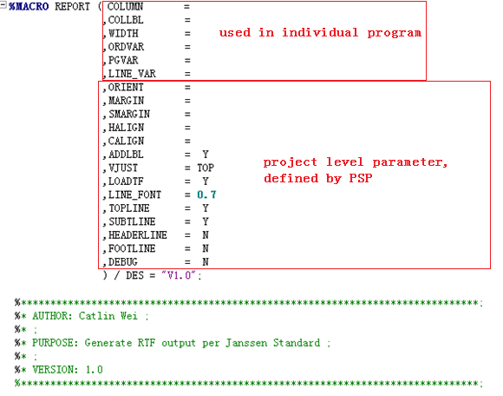

For example, if you want to align the Header as center for the whole project, then change “,HALIGN=” to “,HALIGN=C”.

For production side programmers, just include the parameter you need in individual program, such as “COLUMN COLLBL WIDTH ORDVAR PGVAR LINE_VAR”. Once you put Project-level parameter to individual program, when the project change output style through %report, you output will not be updated. In other words, if you include all parameters of %report in your individual program, then these programs will be out of control by %report.

Below is some samples to set project-level %report parameter. About the detail information for each parameter, see the interpretation in macro. All the parameters work independently, which means you can custom more flexible output by different combinations of the parameters showed in the following samples.

### 1.3.2 Special cases.

### Sample 1: Set project-level header align to center.

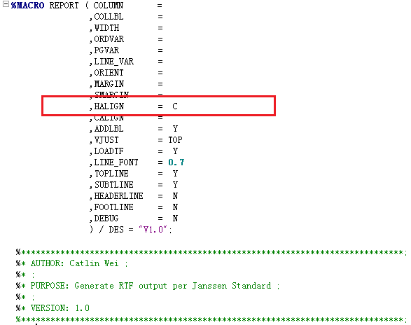

Below is the code and output of LSIDEM03. Make sure HALIGN is not in individual program.

%LET PGID=LSIDEM03;

/***Your program to generate listings.lsidem03 here.***/

%***REPORT*** ( COLUMN = col1 col2 col3 col4 col5

,WIDTH = **20** **25** **20** **15** **18**

,COLLBL = Treatment Group|Subject ID|Treatment Required$(Baseline/ Postbaseline)|Study Day of$Treatment$Initiation|Treatment Initiated

,LINE_VAR = COL2

,ORDVAR = col1 col2 col3

);

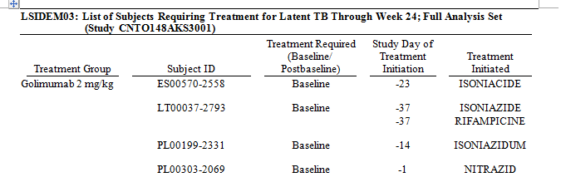

Now all the column headers are center justified.

### Sample 2: Custom project-level MARGIN and SMARGIN.

Custom project-level MARGIN and SMARGIN, which affect header and spanning header respectively.

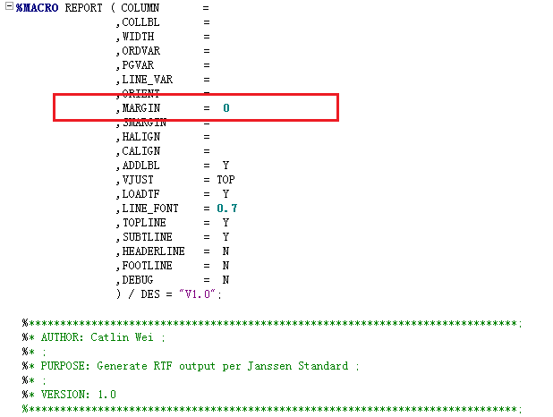

Below is the code of TSIDEM01.

%LET PGID=TSIDEM01;

/***Your program to generate tables.tsidem01 here.***/

%REPORT ( COLUMN = GRPX1 item1 ("\brdrb\brdrs header1" COL1 COL2) ("\brdrb\brdrs header2" COL3)

,WIDTH = 30 10 15 10

,COLLBL = |Placebo|Golimumab 2 mg/kg|Total

,LINE_VAR = GRPX1

,PGVAR = GRPX2

);

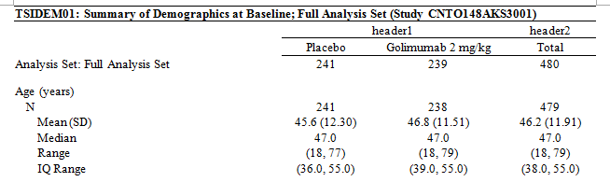

After you set MARGIN=0, the underline of header will not be separated. And in the same time, you get connected spanning headers. If you want the spanning header be separated, you can set SMARGIN=3pt.

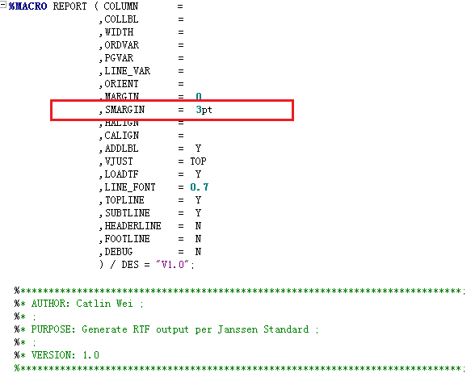

Code for TSIDEM01 will not change, but the output will be adjusted.

%REPORT ( COLUMN = GRPX1 item1 ("\brdrb\brdrs header1" COL1 COL2) ("\brdrb\brdrs header2" COL3)

,WIDTH = 30 10 15 10

,COLLBL = |Placebo|Golimumab 2 mg/kg|Total

,LINE_VAR = GRPX1

,PGVAR = GRPX2

);

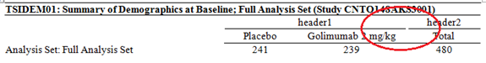

You may notice that there is not underline for the first column, if you want it, then refer to the follow code.

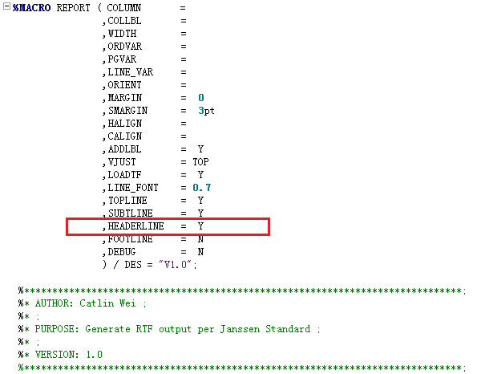

The individual code is same with above. Here is the output.

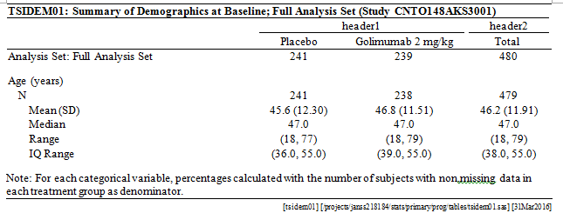

Further, you can add topline for footnote, See below.

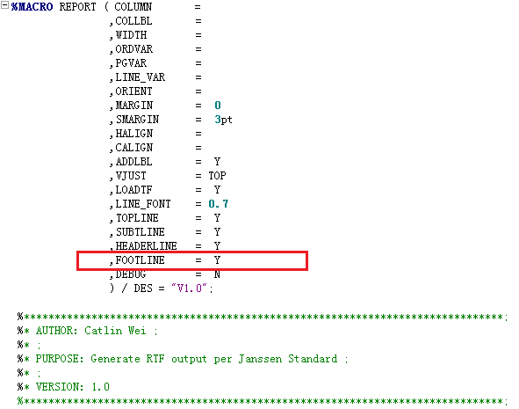

With the same individual code, you can get the following output now.

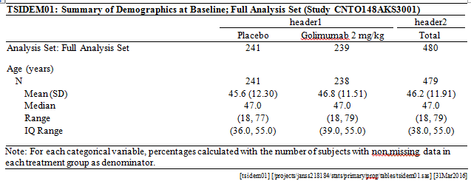

## 1.4 Step 4: Custom project level title-footnote style through %loadtf.

Before you use %loadtf, you need to generate a dataset named UTILITY.TF through macro %utility (refer to Chapter 5) which contains title and footnote for each TLF.

For now, %loadtf just have one parameter PGN, which is set to &PGID by default. It tells %loadtf for which TLF you want to load the title and footnote. You don’t need to care about parameter LS now.

At the end of %loadtf, you can custom the title, footnote, subfoot for your project, or you can just use the default since it’s accord with Janssen standard. The style you set under %loadtf is project-level. When you change the set, you change the whole project. I’ll show you how to custom TLF-level title-footnote in Chapter 2 in case when there is some tlfs need different title-footnote style with most of other tlfs in specific project.

### 1.4.1 Default setting follow Janssen standard.

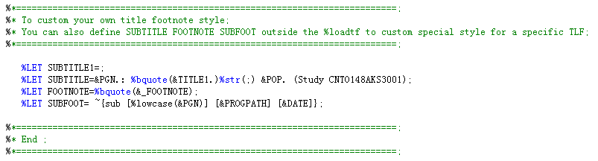

I’ll still take TSIDEM01 for example, show you how to custom title and footnote for specific project. The %report and individual code used here is same with sample 2 of %report. Here is the output from defat setting, you can make a contrast.

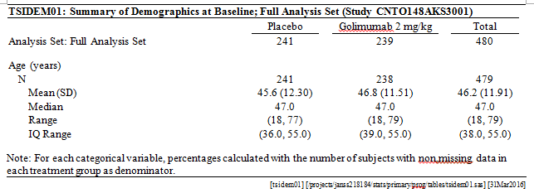

The following samples is to custom title, each sample shows the code and output. You can custom the footnote in similar ways. I have to say that the %loadtf is very flexible, it can cover most of the shells you have seen. I can’t list them one by one, just listed some representative ones.

### 1.4.2 Special cases.

### Sample 1: Add a sub-header with underline.

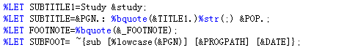

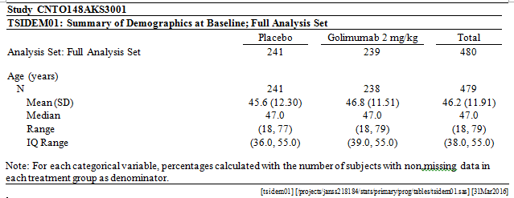

### Sample 2: Add a sub-header without underline.



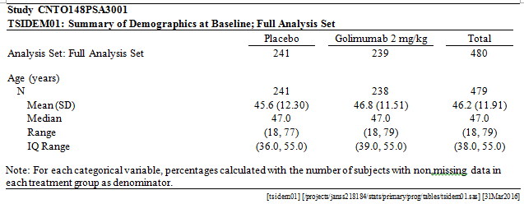

### Sample 3: Add a blank line between the two headers.



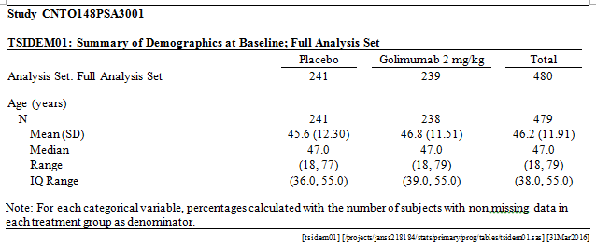

### Sample 4: add subtitle on the right top.

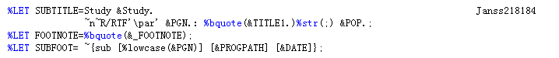

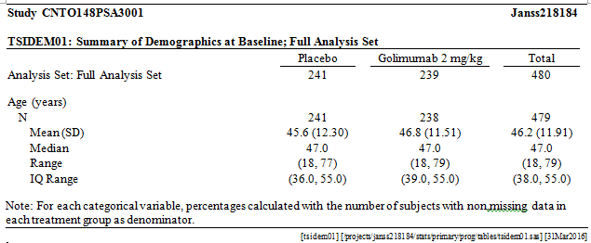

### Sample 5: No topline in the table.

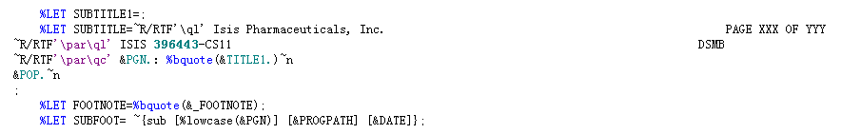

Parameters in %report

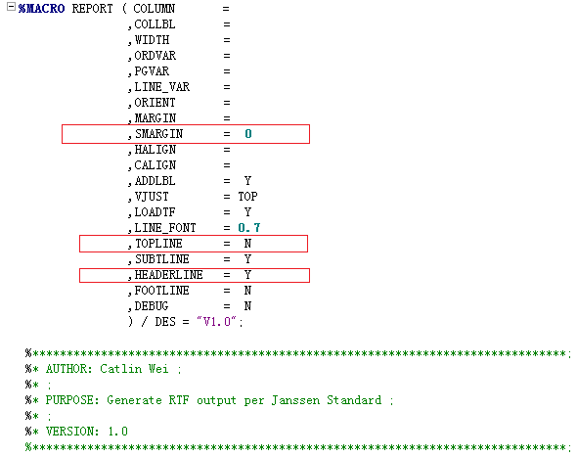

Below is the output for tsidem01.

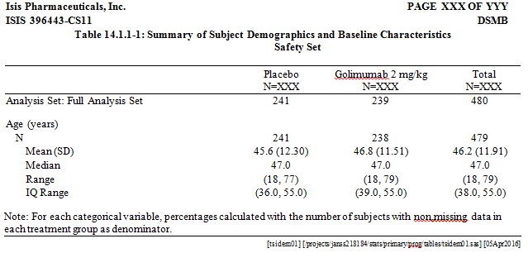

By default, we only replace PAGE XXX OF YYY to real page number in listings. If you also contain PAGE XXX OF YYY in tables, you can do the following change in %report.

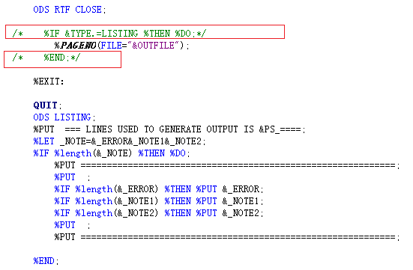

Considering that for most Janssen studies we don’t need to show page numbers in tables, if you need, then do the changes above to %report.

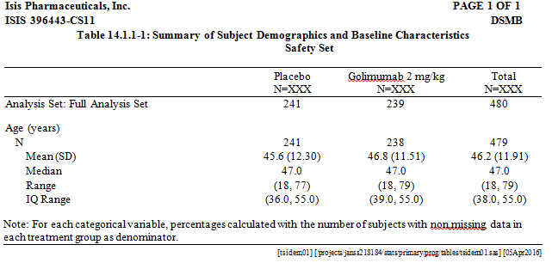

# 3. Usage of %report and %loadtf in individual program (Main side).

In most circumstance, you only need 6 parameters when do TLs, which are COLUMN, COLLBL, WIDTH, ORDVAR, PGVAR, LINE_VAR. Only three parameters are compulsive, which means if individual program don’t contain COLUMN, COLLBL, or WIDTH, %report will stop and not do report.



Requirement for your datasets:

Before using %report, you need to generate your final dataset first, which is tables.&PGID or listings.&PGID. This dataset should only include variables start with item, col, grpx. Variables start with item and col will be output to final rtf file, and variables start with grpx will be used to do order or do pagebreak. If you want to control pagebreake, you also need to generate a variable to control page number in your dataset.

COLUMN: Just treat it as the column statement in report procedure. What you need to put into column statement, just put it to COLUMN, the usage is same.

COLLBL: You only need to define COLLBL for variables start with ITEM and COL listed in COLUMN. The COLLBL for different variable should be separated with “|”, and when you want to split a COLLBL for specific variable to two or more lines, just add “$”. Variable labels in COLLBL should appear in the same order with the variable appear in COLUMN.

WIDTH: The variable width should be defined in same order with COLLBL, and only define WIDTH for variables start with ITEM and COL. WIDTH should be separated with a blank “ “, and make sure total width is less than 99.

ORDVAR: The variable you defined as ORDER in report procedure, you will need an order variable when you want the same value for it only appear once. When you define an order variable, you must also define a PGVAR, or your output can’t display correctly when starting a new page. The default order is internal, sometimes you need to add some numeric GRPX variables when you want to order character variables.

PGVAR: As mentioned before, it’s used to control pagebreak.

LINE_VAR: When you want to add a blank line between different catergory.

Some parameters you may also need. Pay attention: only include them when the default set can’t satisfy your need.

ORIENT: To control the orientation of page layout. Values: PORTRAIT, LANDSCAPE.

HALIGN: To control align of headers. Values: C, L, R. If all variables share the same align, for example, you want all headers be center justified, then let HALIGN=C, otherwise you need to define the same number of align for variables start with ITEM and COL, and separate them with a blank.

CALIGN: Align for columns. Values: C, L, R. If all variable need the same align for column, then define it once, otherwise define it for each display variable. The default CALIGN is that, left justify the first column and center justify the rest. This works for most tables, but some listings may need to define it in individual program.

ADDLBL: Since we have defined the column label in COLLBL, if you need to add label in your tables.&pgid or listing.&pgid, you just need to set ADDLBL=Y. Then you don’t need to generate label in your dataset by a label or attrib statement. By default, it will add label to dataset.

## 3.1 Tables

I will cast samples here, you can find the interpretation of each parameter above.

3.1.1 Standard code.

dm "log; clear; out; clear;";

**proc** **datasets** nolist lib=work memtype=data kill;**run**;

/* -------------Program body--------------------- */

%LET PGID=TSIDEM01;

/***Your program to generate tables.tsidem01 here.***/

%REPORT ( COLUMN = GRPX1 item1 COL1 COL2 COL3

,WIDTH = 30 10 15 10

,COLLBL = |Placebo|Golimumab 2~{unicode 00A0}mg/kg|Total

,LINE_VAR = GRPX1

,PGVAR = GRPX2

);

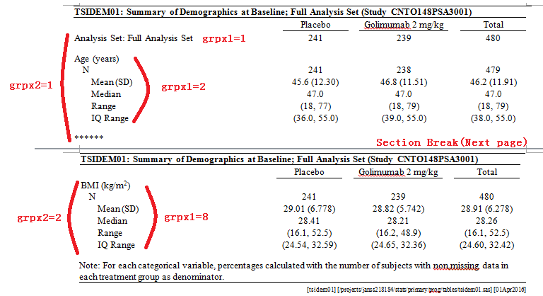

By the way, below is how to do indentation and how to do align for 0 in your program.

I should do some explanation to &ri7. Firstly, please put it on the left hand of 0, we should uniform to simplify QC; secondly, 7 means you add 7 blank spaces to the right side of 0. If you need 8, then you should use &ri8.

The &ri7 &ri8 should be defined in setup.sas as global macro variables.

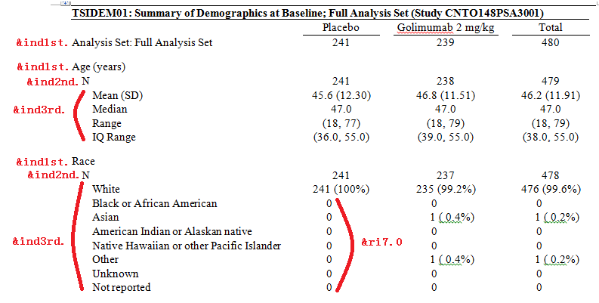

### 3.1.2 Special cases.

### Sample 1 display title in different style from default setting.

For example, you need to do table by Sex: Male and Sex: Female. And the shell is as below. If you need more styles, you can refer to step 4 in chapter2.

Since your title/footnote style is different, you can’t use project-level %loadtf under your %report any more. Then first, add an option to %report in your individual program like below.

%REPORT ( COLUMN = GRPX1 item1 COL1 COL2 COL3

,WIDTH = 30 10 15 10

,COLLBL = |Placebo|Golimumab 2~{unicode 00A0}mg/kg|Total

,LINE_VAR = GRPX1

,PGVAR = GRPX2

,LOADTF = N

);

After that, you can design your own title footnote style.

1) Generate global macro variables about the basic information of title and footnote about the current table, code is below.

%loadtf ( pgn = &pgid );

Then you get the follow global macro variables:

SUBTITLE SUBTITLE1 TITLE1 _NFOOT FOOTNOTE SUBFOOT POP _NLINET _NLINEF PROGRAM PROGPATH DATE

1) Copy the default set of title/footnote from %loadtf, you can copy just the ones that you need to change.



For example, I want to change SUBTITLE1.

%LET SUBTITLE1=Sex: Female;

Ok, below is the program be put together.

**%LOADTF** ( PGN = &PGID );

%LET SUBTITLE1=Sex: Female;

**%REPORT** ( COLUMN = GRPX1 item1 COL1 COL2 COL3

,WIDTH = 30 10 15 10

,COLLBL = |Placebo|Golimumab 2~{unicode 00A0}mg/kg|Total

,LINE_VAR = GRPX1

,PGVAR = GRPX2

,LOADTF = N

);

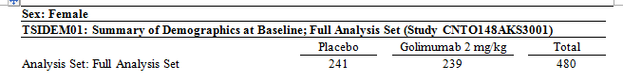

Mostly, we don’t like the line on the top, then add topline=N in %report.

**%LOADTF** ( PGN = &PGID );

%LET SUBTITLE1=Sex: Female;

**%REPORT** ( COLUMN = GRPX1 item1 COL1 COL2 COL3

,WIDTH = 30 10 15 10

,COLLBL = |Placebo|Golimumab 2~{unicode 00A0}mg/kg|Total

,LINE_VAR = GRPX1

,PGVAR = GRPX2

,LOADTF = N

,TOPLINE = N

);

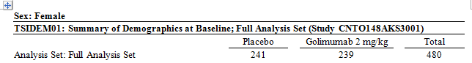

You can design your footnote through the same way. Basicly, you can custom various title/footnote style, as long as you can imagine it out. I’ll not list them one by one here.

## 3.2 Listings

You must define a variable to control page break in your dataset for listings, otherwise all the pages in your output will display “PAGE 1 of 1”.

The product of Listings is similar with the product of Tables, I just illustrate the difference here. Below is sample for ORDVAR. Usually, you need to define ORDVAR to display the variable value one time for equal values.

dm "log; clear; out; clear;";

**proc** **datasets** nolist lib=work memtype=data kill;**run**;

/* -------------Program body--------------------- */

%LET PGID=LSIDEM03;

/***Your program to generate tables.tsidem01 here.***/

**%REPORT** ( COLUMN = GRPX1 COL1 GRPX2 COL2 COL3 COL4 COL5

,WIDTH = 20 25 20 15 18

,COLLBL = Treatment Group|Subject ID|Treatment Required$(Baseline/ Postbaseline)|Study Day of$Treatment$Initiation|Treatment Initiated

,LINE_VAR = COL2

,ORDVAR = GRPX1 COL1 GRPX2 COL2 COL3

,PGVAR = GRPX99 );

Here, you want “Placebo” appear before “Golimumab”, so you must add a GRPX variable equal to the numeric treatment group to do the order, you can also use GRPX2=USUBJID to sort SUBJID.

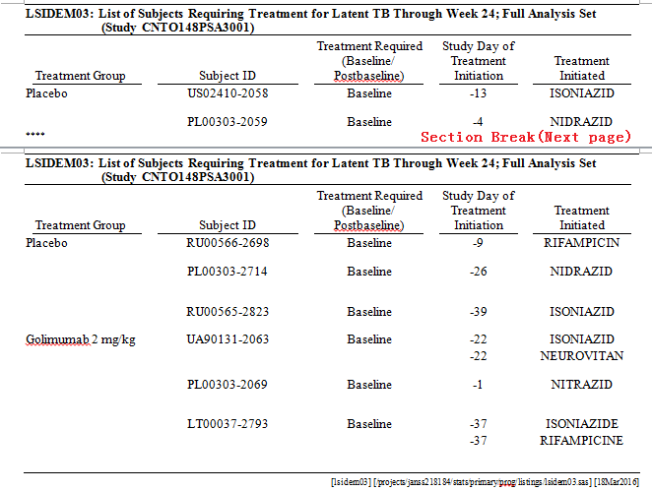

Also, usually we want all the columns in the output be center justified, then add another option CALIGN=C.

**%REPORT** ( COLUMN = GRPX1 COL1 GRPX2 COL2 COL3 COL4 COL5

,WIDTH = 20 25 20 15 18

,COLLBL = Treatment Group|Subject ID|Treatment Required$(Baseline/ Postbaseline)|Study Day of$Treatment$Initiation|Treatment Initiated

,CALIGN = C

,LINE_VAR = COL2

,ORDVAR = GRPX1 COL1 GRPX2 COL2 COL3

,PGVAR = GRPX99 );

## 3.3 Figures

For figures, you don’t need %report, but you need to use the same ods rtf file statement with %report to make sure you followed the required definition. You can use %loadtf to generate global macro variables for your title and footnote, and you can change the title/footnote style by yourself. Below is an example.

%***LOADTF***(PGN=&PGID);

ODS RTF FILE="&OUTFILE" STYLE=GLOBAL.&TYPE.S HEADERY = **1** WORDSTYLE= "{\s1 Caption;}{\s2 Heading 1;}"

;

ODS RTF TEXT="~S={outputwidth=99.99% protectspecialchars=on}~R/RTF'\brdrt\brdrs\brdrb\brdrs\brdrw10\fs3' ~R/RTF'\par\fs20\b\ql\fi-1152\li1152'&SUBTITLE";

ODS GRAPHICS / RESET NOBORDER IMAGEFMT=JPG WIDTH=**8**in HEIGHT=**5**in NOSCALE;

PROC SGRENDER DATA=FIGURES.&DATA TEMPLATE=PROFILE;

DYNAMIC TITLE=" ";

RUN;

ODS RTF TEXT="~S={outputwidth=99.99% protectspecialchars=on}&FOOTNOTE";

ODS RTF TEXT="~S={textalign= r just=r outputwidth=99.99% protectspecialchars=on}~R/RTF'\brdrt\brdrs\brdrw10'&SUBFOOT";

# 4. An excellent helper: %utility

To import titlefootnote: %utility(out=TF)

To generate multirun file: %utility(out=multirun)

To generate multirun file for tlf: %utility(out=multirun,type=tlf)

To generate multirun file for ad: %utility(out=multirun,type=ad)

To generate multirun file for author Catlin: %utility(out=multirun,author=catlin)

To generate DTA: %utility(out=DTA)

You can select batch 1 or batch 2 through the WHERE parameter.

Attachment 1: SAS options used in SETUP.

**NOTHREADS**: specifies not to use threaded processing for running SAS applications that support it.

**NOQUOTELENMAX**: specifies that SAS does not write a warning for the maximum length for strings in quotation marks to the SAS log.